Creating and Editing Survey 123 Forms
- Download the Survey123 Connect Desktop app
- Start the app and logon using your ArcGiS credentials
- Click the New Survey button

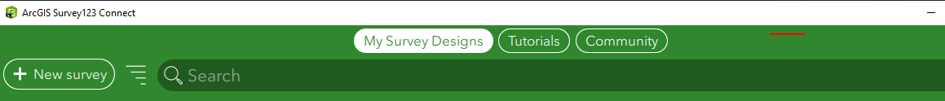

- Title your survey e.g. “Hydrometric Field Data Collection” then Create Survey

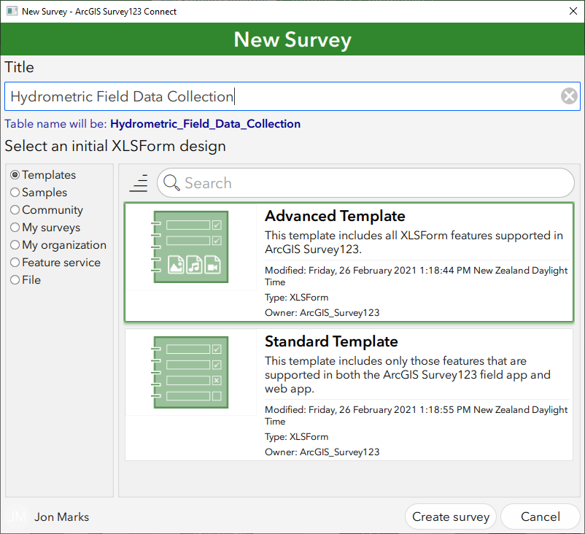

- A sample form along with its related xlsx form will open.
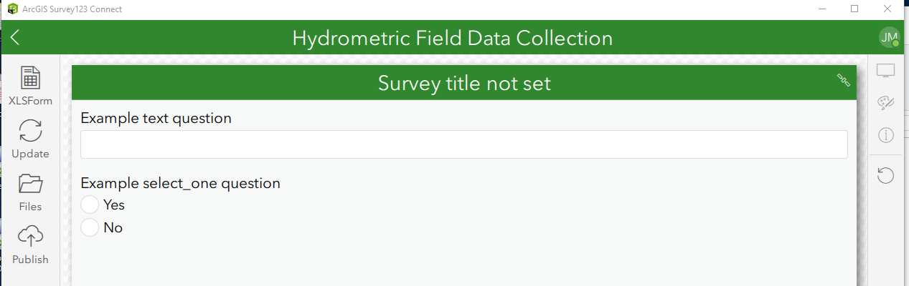

- Close the xlsx and click the Files icon, this will open the file location of the xlsx file

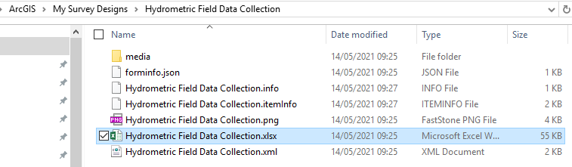

- Copy in the NEMS template. Delete the default xlsx file was automatically created and rename the template to be exactly the same as the old xlsx file.

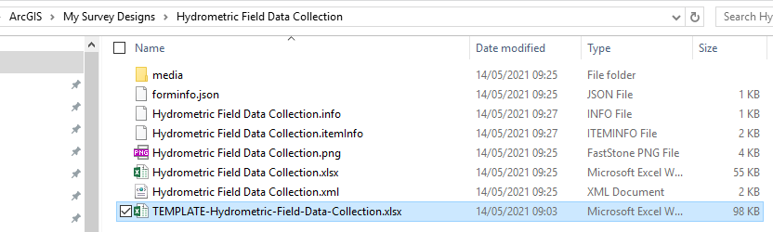

- Back in Survey123 Connect, click the Update button. The Survey123 form will load and you will be able to test it.
- You will need to update the location names and staff names for your organisation, this is done by editing the lists in the xlsx file, if you do not have the file open you can click the XLSForm button.
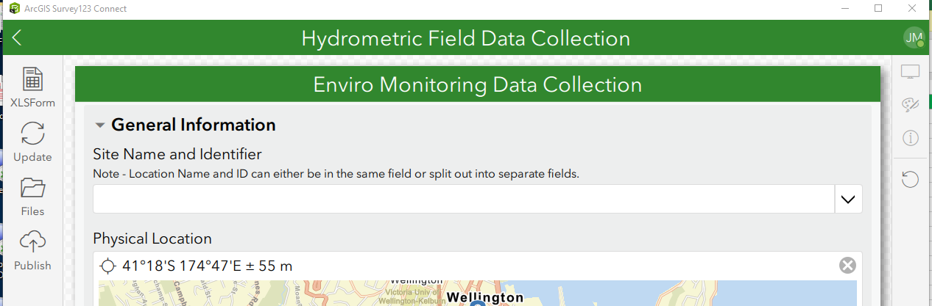

- Click the Choice tab on the xlsx file.

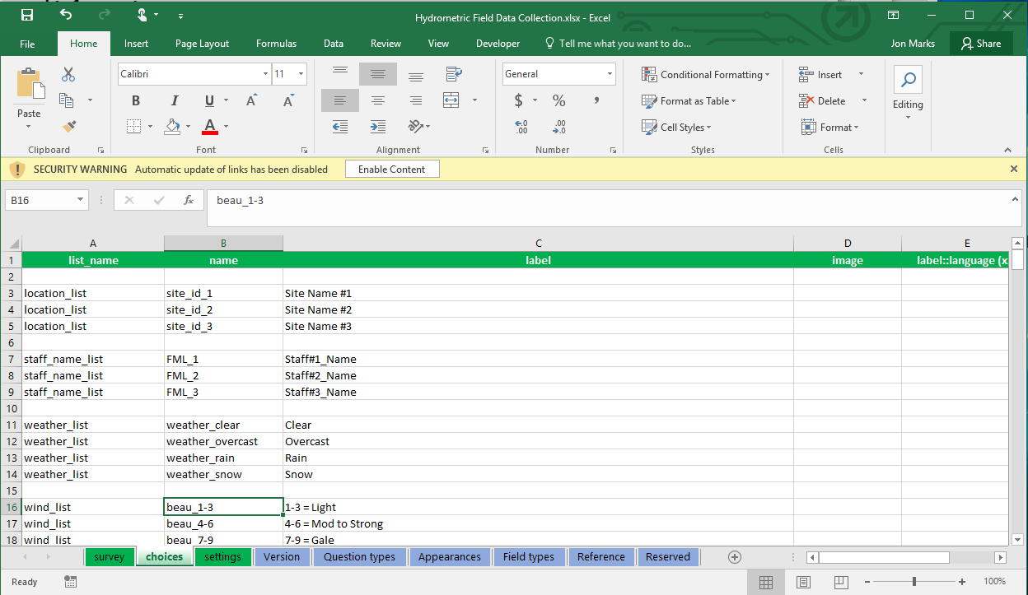

- Add or edit the location_list and staff_name_list options as required, you cannot use spaces, certain characters or reserved words in the name column. Reserved words are listed in the Reserved tab. Save the file, this will refresh the form in Survey123 Connect.
- When you have made any relevant changes to the xlsx and refreshed the form in Survey123 Connect you can then publish the file. You may need to talk to your GIS colleagues to assist you with accessing the data via ArcGIS Online. Python scripts can be used to download the data for use in other software/databases.

